***IS456:2000 COLUMN CODE PROVISIONS***

Column definition Column Effective Length > 3 x Minmum(b,d) **[IS456:2000 25.1.1]**

Short Column EffectiveLength(lx)/D < 12 and ly/b < 12 **[IS456:2000 25.1.2]**

Long Column EffectiveLength /D >= 12 or y/b >= 12  **[IS456:2000 25.1.2]**

Slenderness Limit

End Restrained: UnsupportedLength <= 60 x Minimum(b,d) **[IS456:2000 25.3.1]**

One end Unrestrained(cantilever): UnsupportedLength <= 100 b2 /D **[IS456:2000 25.3.2]**

Minimum Eccentricity **[IS456:2000 24.4]**

Min of below

UnsupportedLength(l)/500 + RespectiveLateralDimension(b,d)/30

20 mm

Cover Minimum Cover >= 40 **[IS456:2000 26.4.2.1]**

Min dimension >= 200 that is only for column if dia not exeed 12 and cover 12 mm

who have bars dia <=12 only and cover =25 can be use **[IS456:2000 26.4.2.1]**

Min Reinforcement **0.008 b d** (gross cross section) **[IS456:2000 26.5.3.1]**

Max Reinforcement **0.06 b d** (gross cross section) **[IS456:2000 26.5.3.1]**

**Minimum no of bars is [IS456:2000 26.5.3.1_c]**

4 in Rectangular Column

6 in Circle Column

Min Bar diameter **dia >=12 mm [IS456:2000 26.5.3.1_d]**

Max spacing of main bar along Peiphery outer edge **spacing <= 300 [IS456:2000 26.5.3.1_h]**

**Lateral ties min spacing**  **[IS456:2000 26.5.3.2_c]**

Min of below 3

Min (b,d)

16 Dia(longitutional)

300

**Dia of tie/Helical [IS456:2000 26.5.3.2_d]**

Max of below :

¼ dia of large longitudinal bar

16

**Pitch of tie/Helical [IS456:2000 26.5.3.2_d]**

Max pitch

Min of below

1/6 x Dia of column

75

Min pitch

Max of below

3 x Dia of helix bar

25

* Max Compressive Strain in concrete ‘Concrete in Compressive only’

**0.002 [IS456:2000 39.1]**

* Max Compressive Strain in concrete concrete ‘Concrete in Compressive and bending’ when there is no tension in the section

**0.0035 – 0.75 x strain in least compressive fibre [IS456:2000 39.1]**

**Short Axially Loaded Column**   **[IS456:2000 39.3]**

Le/b < 12 short column

UnsupportedLength(l)/500 + RespectiveLateralDimension(b,d)/30 <= 0.05 x Lateral Dimension <= 20

Pu = 0.4 fck Ac + 0.67 fy Asc

**Compression Members with Helical Reinforcement** **[IS456:2000 39.4]**

Pu = (0.4 fck Ac + 0.67 fy Asc ) x 1.05 of tie section

**Area of helical Reinforcenment** >= 0.36(Ag/Ac - 1) fkc/fy

**Members Subjected to Combined Axial Load and Biaxial Bending [IS456:2000 39.6]**

This ensure that this that member is with in the Circle or curve dose not fail

***= Pu/ Puz***

***Puz =*** 0.45fck Ac + 0.75 fy Asc  

**Slender compession members [IS456:2000 39.7]**

Additional Moment

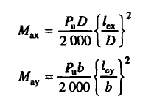

Reduction Factor **[IS456:2000 39.7.1.1]**

**

Concrete Shear Capacity  **[IS456:2000 40.4 c] [T table 19]**

***Shear Strength of Members Under axial [*IS456:2000  *40.2.2]***

*Design shear strength of table119 must multiply with factor*

*Detla = 1 + 3 Pu / Ag fck*

***Tc*** *x Delta*

Design Shear Strength of Concrete ***Tc [*IS456:2000 *Table 19]***

*Shear Strength of Concrete* ***Tc*** ***[SP 24 39.2.1]***

*Shear Strength of Concrete Tcmax*  ***[Table 20 , SP 16 pno124]***

Reinforce Shear Capacity   **[IS456:2000 40.4 c]**

Minimum shear reinforcement **[IS456:2000 26.5.1.6]**

**Effective Length [IS456:2000 Annex E ]**

As PER Table 28 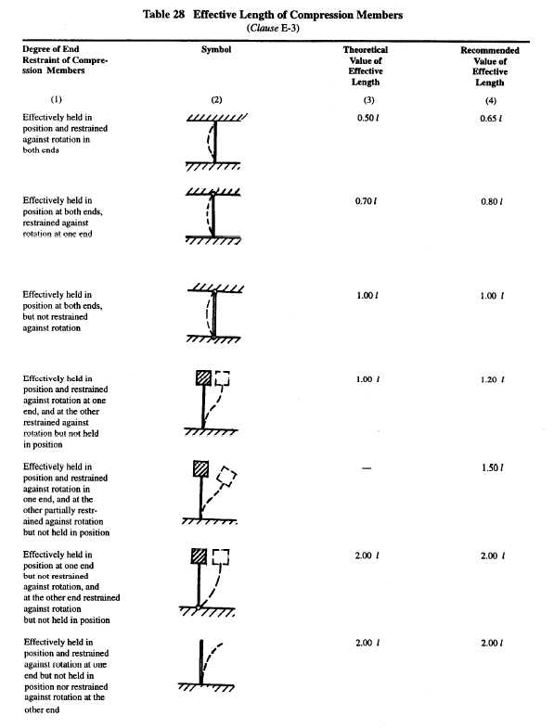

**Serviceability for Compression Member [IS456:2000 43.2]**

To considered flexural member for purpose of crack control

Axial load **<=** 0.2 fck Ac

**Design surface Crack Width**  **[IS456:2000 Annex F]**

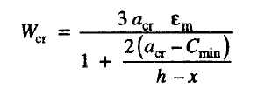

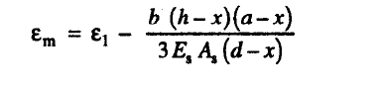

**Cracking Limits** **[IS456:2000 35.3.2]**

For Appearance Condition Crack Width Not Exceed 0.3 mm

For Moderate Exposer Condition Crack Width Not Exceed 0.2 mm

For Severe Exposer Condition Crack Width Not Exceed 0.1 mm

For Aggressive Condition Crack width not Exceed 0.004 mm

**Splicing**  **[IS456:2000 26.5.5.1]**

Lap splices

Ø ≤ 36 mm

If ø ≥ 36 mm provide spirals around lapped bar

++

**Maximum Allowable Spacing of shear steel [IS456:2000 26.5.1.5]**

Min of below

0.75 d

300

**Minimum****Distance between Individual Bars *[*IS456:2000 26.3.2]**

Not greater than this :

Dia of Large Bar

5mm + 20aggregate size

Check ratio of tensile reinforcement

Calculate Neutral axis  **[IS456:2000 ANNEX G]**

Calculate Moment Capacity  **[IS456:2000 ANNEX G]**

Calculate Moment Capacity compression steel  **[IS456:2000 ANNEX G 1-2]**

xu.max the limiting value of xU **xu.max** **[IS456:2000 38.1]**

***Stress in Compression Steel fsc*  [IS456:2000 Annex G 1.2]**

***Xu / d Limit [*IS456:2000 *Table 20 , SP 16 pno124]***

**IS 13920 DUCTAIL DETAILING [IS13920:2016]**

**Minimum Column width [IS13920:2016 7.1.1]**

**Max of Below**

>= 300

>= 20 Diameter_Longitudinal_Large_bar

**Smaller_section_dimension to Larger_section_dimension <= 0.45 [IS13920:2016 7.1.2]**

b/d <=0.45

Circular column minimum of **6** bars **[IS13920:2016 7.3.1]**

**If Splicing [IS13920:2016 7.3.2.1]**

Link spacing <= 100 mm spacing

mainBar Dia <= 32 mm

Hook **135** degree and must extend 6 times its diameter and >=65 mm **[IS13920:2016 7.4.1]**

Show in Drawings

**Links spacing [IS13920:2016 7.4.2]**

Minimum bar Dia >= 8mm

Maximum bar Dia <= 32mm

If Dia of long bar is 32 mm then minimum bar dia <= 10

Max spacing links(TieBar) <= 300

Spacing<= ½ min(b,d)

If length of link is >= 300 provide cross link

**Shear Force in Columns** sagging-hogging **[IS13920:2016 7.5]**

For Sway to Right Vu = 1.4 (MuAs  + MuBh )/hst

For Sway to Left Vu = 1.4 (MuAh  + MuBs )/hst

**SPECIAL CONFINING REINFORCEMENT**

Cross section area of bar **Link or spiral** Over length lo  **[IS13920:2016 8.1.3]**

**Ash** Max of below

0.09 Sv Dk  fck/fy (Ag/Ak – 1 )

0.24 sv Dk fck / fy

Cross section area of bar **Link or Rectangle** Over length lo **[IS13920:2016 8.1.3]**

**Ash** Max of below

0.18 Sv sh h fck/fy (Ag/Ak – 1 )

0.05 sv h fck / fy